**ASSIGNMENT – 7**

**NAME:**B.YOGENDRA

**REG NO:**192325046

**COURSE:**DAA

**COURSE CODE:**CSA0678

**1) . Convert the Temperature You are given a non-negative floating point number rounded to two decimal places celsius, that denotes the temperature in Celsius.You should convert Celsius into Kelvin and Fahrenheit and return it as an array**

def convert_temperature(celsius):

kelvin = celsius + 273.15

fahrenheit = celsius * 1.80 + 32.00

return [round(kelvin, 5), round(fahrenheit, 5)]

celsius = 36.50

result = convert_temperature(celsius)

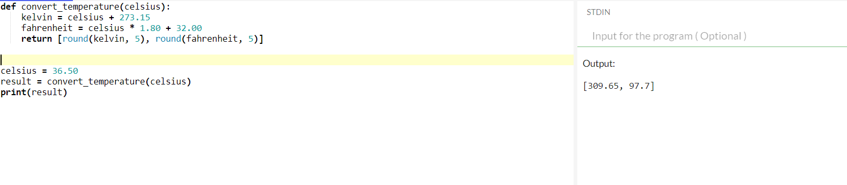print(result)

**2) Given an integer array nums and an integer k, return the number of subarrays of nums where the least common multiple of the subarray's elements is k.A subarray is a contiguous non empty sequence of elements within an array.The least common multiple of an array is the smallest positive integer that is divisible by all the array elements.**

import math

from functools import reduce

from math import gcd

def lcm(x, y):

return abs(x * y) // gcd(x, y)

def lcm_of_list(lst):

return reduce(lcm, lst)

def count_subarrays_with_lcm(nums, k):

count = 0

n = len(nums)

for i in range(n):

current_lcm = 1

for j in range(i, n):

current_lcm = lcm(current_lcm, nums[j])

if current_lcm == k:

count += 1

if current_lcm > k:

breaK

return count

# Example usage

nums = [3, 6, 2, 7, 1]

k = 6

result = count_subarrays_with_lcm(nums, k)

print(result)

Output: 4

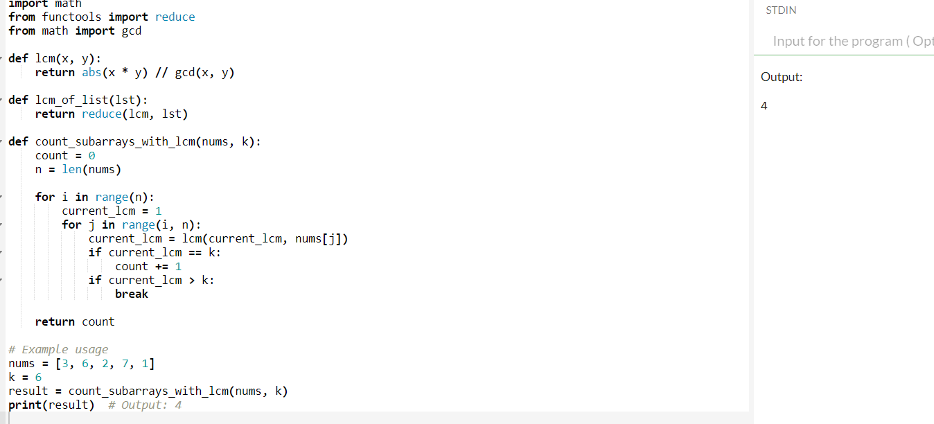

**3) You are given the root of a binary tree with unique values.In one operation, you can choose any two nodes at the same level and swap their values.Return the minimum number of operations needed to make the values at each level sorted in a strictly increasing order. The level of a node is the number of edges along the path between it and the root node.**

from collections import deque

# Definition for a binary tree node.

class TreeNode:

def __init__(self, val=0, left=None, right=None):

self.val = val

self.left = left

self.right = right

def minSwapsToSort(arr):

n = len(arr)

arrpos = [(value, index) for index, value in enumerate(arr)]

arrpos.sort()

vis = {k: False for k in range(n)}

ans = 0

for i in range(n):

if vis[i] or arrpos[i][1] == i:

continue

cycle_size = 0

x = i

while not vis[x]:

vis[x] = True

x = arrpos[x][1]

cycle_size += 1

if cycle_size > 0:

ans += (cycle_size - 1)

return ans

def minOperationsToSortLevels(root):

if not root:

return 0

queue = deque([root])

min_operations = 0

while queue:

level_size = len(queue)

level_nodes = []

for _ in range(level_size):

node = queue.popleft()

level_nodes.append(node.val)

if node.left:

queue.append(node.left)

if node.right:

queue.append(node.right)

min_operations += minSwapsToSort(level_nodes)

return min_operations

# Example usage:

# Construct the binary tree from the given example

root = TreeNode(1)

root.left = TreeNode(4)

root.right = TreeNode(3)

root.left.left = TreeNode(7)

root.left.right = TreeNode(6)

root.right.left = TreeNode (8)

root.right.right = TreeNode(5)

root.right.left.left = TreeNode(9)

root.right.left.right = TreeNode(10)

# Calculate the minimum number of operations

result = minOperationsToSortLevels(root)

print(result)

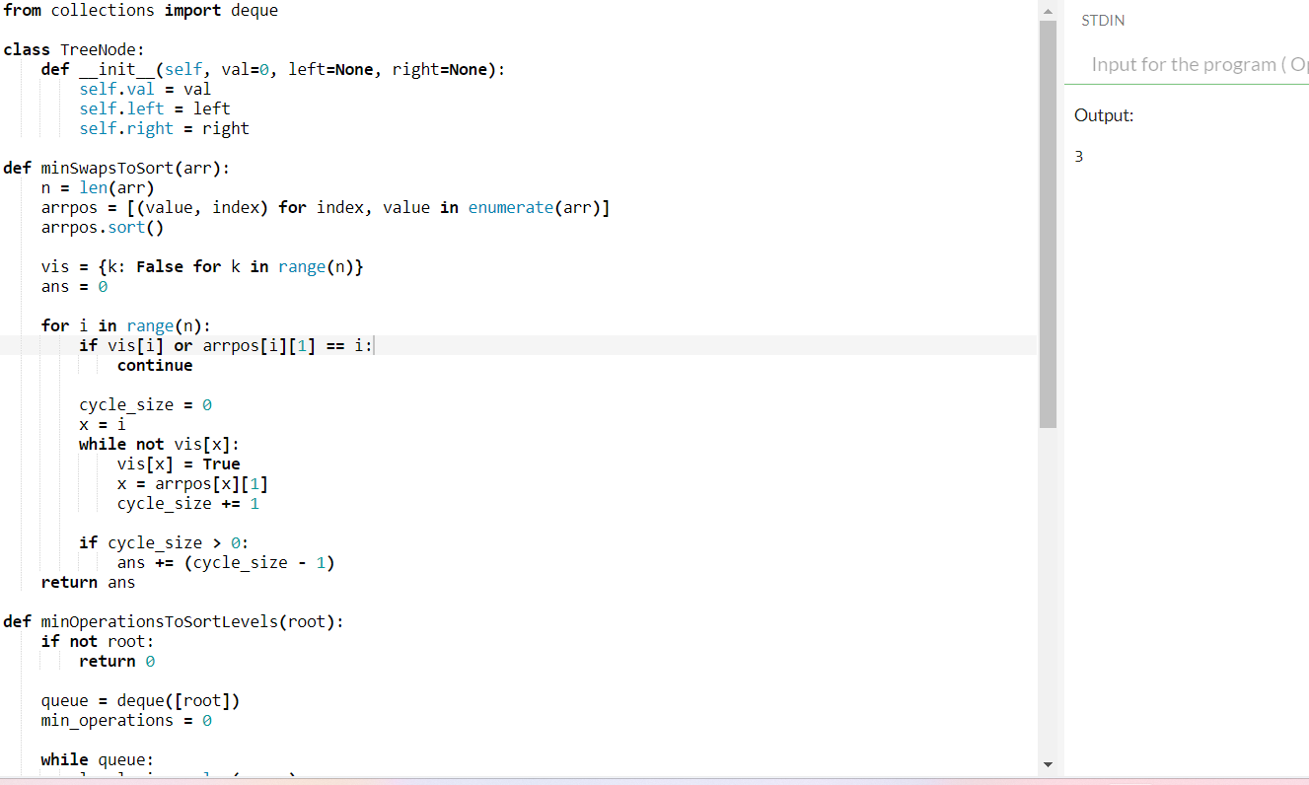

**4) You are given a string s and a positive integer k.Select a set of non-overlapping substrings from the string s that satisfy the following conditions: ● The length of each substring is at least k. ● Eachsubstring is a palindrome. Return the maximum number of substrings in an optimal selection.A substring is a contiguous sequence of characters within a string.**

def maxPalindromicSubstrings(s, k):

n = len(s)

dp = [[False] * n for _ in range(n)]

# Populate dp table for palindromic substrings

for length in range(1, n+1):

for i in range(n-length+1):

j = i + length - 1

if length == 1:

dp[i][j] = True

elif length == 2:

dp[i][j] = (s[i] == s[j])

else:

dp[i][j] = (s[i] == s[j] and dp[i+1][j-1])

palindromic_substrings = []

for i in range(n):

for j in range(i + k - 1, n):

if dp[i][j]:

palindromic_substrings.append((i, j))

# Sort by end index to facilitate non-overlapping selection

palindromic_substrings.sort(key=lambda x: x[1])

count = 0

last_end = -1

for start, end in palindromic_substrings:

if start > last_end:

count += 1

last_end = end

return count

# Example usage

s = "abaccdbbd"

k = 3

print(maxPalindromicSubstrings(s, k))

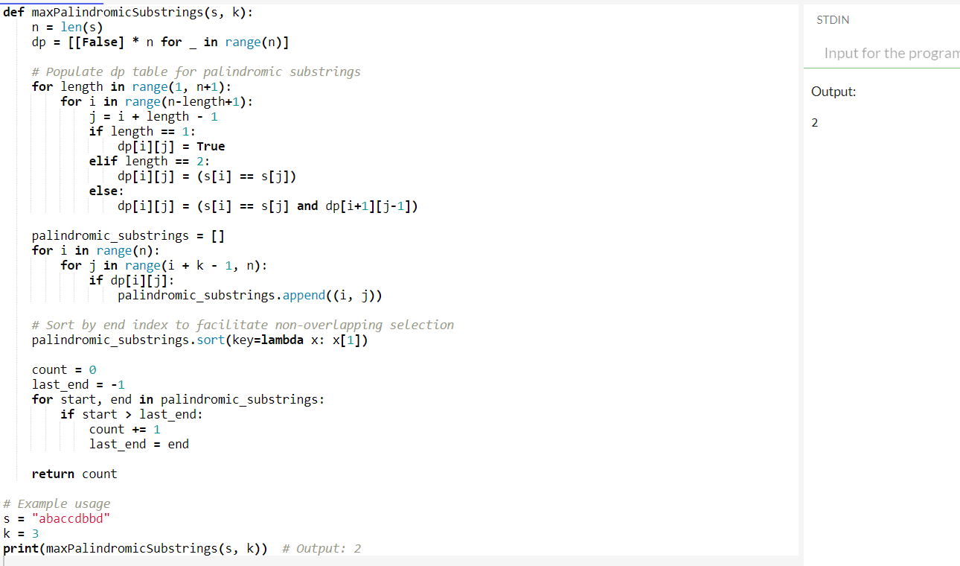

**5) 5. Minimum Cost to Buy Apples You are given a positive integer n representing n cities numbered from 1 to n. You are also given a 2D array roads, where roads[i] = [ai, bi, costi] indicates that there is a bidirectional road between cities ai and bi with a cost of traveling equal to costi. You can buy apples in any city you want, but some cities have different costs to buy apples. You are given the array appleCost where appleCost[i] is the cost of buying one apple from city i.**

import heapq

def dijkstra(n, graph, start):

dist = [float('inf')] * (n + 1)

dist[start] = 0

min_heap = [(0, start)]

while min_heap:

current_dist, u = heapq.heappop(min_heap)

if current_dist > dist[u]:

continue

for v, weight in graph[u]:

distance = current_dist + weight

if distance < dist[v]:

dist[v] = distance

heapq.heappush(min_heap, (distance, v))

return dist

def min_total_cost(n, roads, appleCost, k):

graph = [[] for _ in range(n + 1)]

for u, v, cost in roads:

graph[u].append((v, cost))

graph[v].append((u, cost))

all_costs = []

for i in range(1, n + 1):

dist_from_i = dijkstra(n, graph, i)

min_cost = float('inf')

for j in range(1, n + 1):

if i != j:

cost = dist_from_i[j] + appleCost[j - 1] + dist_from_i[j] * k

min_cost = min(min_cost, cost)

else:

min_cost = min(min_cost, appleCost[j - 1])

all_costs.append(min_cost)

return all_costs

# Example usage

n = 4

roads = [[1, 2, 4], [2, 3, 2], [2, 4, 5], [3, 4, 1], [1, 3, 4]]

appleCost = [56, 42, 102, 301]

k = 2

print(min_total_cost(n, roads, appleCost, k))

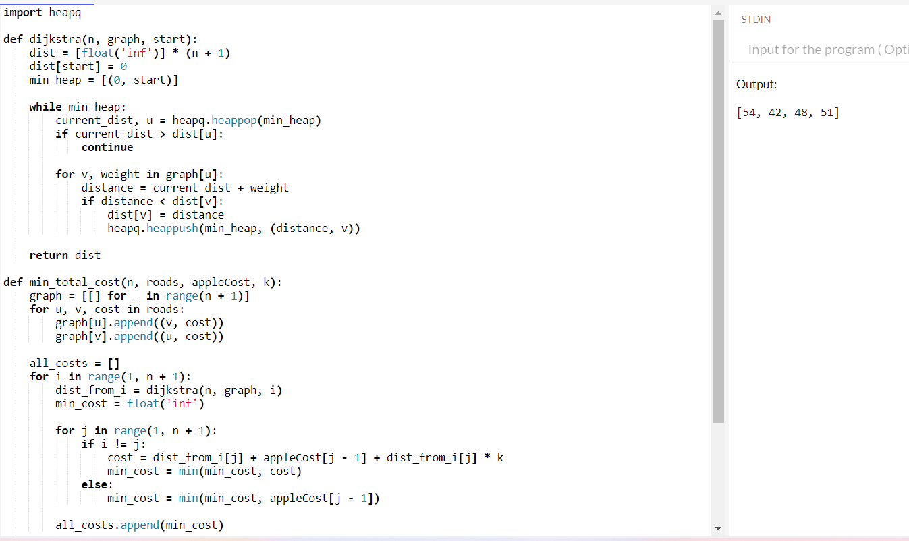

**6) 6. Customers With Strictly Increasing Purchases SQLSchema Table: Orders +--------------+------+ | Column Name | Type | +--------------+------+ | order_id | int | | customer_id | int | | order_date | date | | price | int | +--------------+------+ order_id is the primary key for this table. Each row contains the id of an order, the id of customer that ordered it, the date of the order, and its price. Write an SQL query to report the IDs of the customers with the total purchases strictly increasing yearly. ● Thetotal purchases of a customer in one year is the sum of the prices of their orders in that year. If for some year the customer did not make any order, we consider the total purchases 0. ● Thefirst year to consider for each customer is the year of their first order. ● Thelast year to consider for each customer is the year of their last order. Return the result table in any order.**

import sqlite3

# Create a new SQLite database (or connect to an existing one)

conn = sqlite3.connect(':memory:')

cursor = conn.cursor()

# Create the Orders table

cursor.execute('''

CREATE TABLE Orders (

order_id INTEGER PRIMARY KEY,

customer_id INTEGER,

order_date DATE,

price INTEGER

)

''')

# Insert sample data into the Orders table

orders = [

(1, 1, '2019-07-01', 1100),

(2, 1, '2019-11-01', 1200),

(3, 1, '2020-05-26', 3000),

(4, 1, '2021-08-31', 3100),

(5, 1, '2022-12-07', 4700),

(6, 2, '2015-01-01', 700),

(7, 2, '2017-11-07', 1000),

(8, 3, '2017-01-01', 900),

(9, 3, '2018-11-07', 900)

]

cursor.executemany('INSERT INTO Orders (order_id, customer_id, order_date, price) VALUES (?, ?, ?, ?)', orders)

# Define and execute the SQL query

query = '''

WITH YearlyPurchases AS (

SELECT

customer_id,

strftime('%Y', order_date) AS year,

SUM(price) AS total_price

FROM Orders

GROUP BY customer_id, year

),

CustomerYears AS (

SELECT

customer_id,

MIN(year) AS start_year,

MAX(year) AS end_year

FROM YearlyPurchases

GROUP BY customer_id

),

YearRange AS (

SELECT

customer_id,

year

FROM CustomerYears

JOIN (

SELECT DISTINCT strftime('%Y', order_date) AS year

FROM Orders

) AS Yrs

ON year BETWEEN start_year AND end_year

),

PurchasesWithGaps AS (

SELECT

yr.customer_id,

yr.year,

COALESCE(yp.total_price, 0) AS total_price

FROM YearRange yr

LEFT JOIN YearlyPurchases yp

ON yr.customer_id = yp.customer_id AND yr.year = yp.year

),

RankedPurchases AS (

SELECT

customer_id,

year,

total_price,

ROW_NUMBER() OVER (PARTITION BY customer_id ORDER BY year) AS rn

FROM PurchasesWithGaps

),

Comparison AS (

SELECT

a.customer_id,

a.total_price,

b.total_price AS prev_total_price

FROM RankedPurchases a

LEFT JOIN RankedPurchases b

ON a.customer_id = b.customer_id AND a.rn = b.rn + 1

)

SELECT DISTINCT customer_id

FROM Comparison

GROUP BY customer_id

HAVING COUNT(*) = COUNT(CASE WHEN total_price > prev_total_price THEN 1 END);

'''

# Execute the query and fetch results

cursor.execute(query)

result = cursor.fetchall()

# Print the result

print("Customers with strictly increasing yearly purchases:")

for row in result:

print(row[0])

# Close the connection

conn.close()

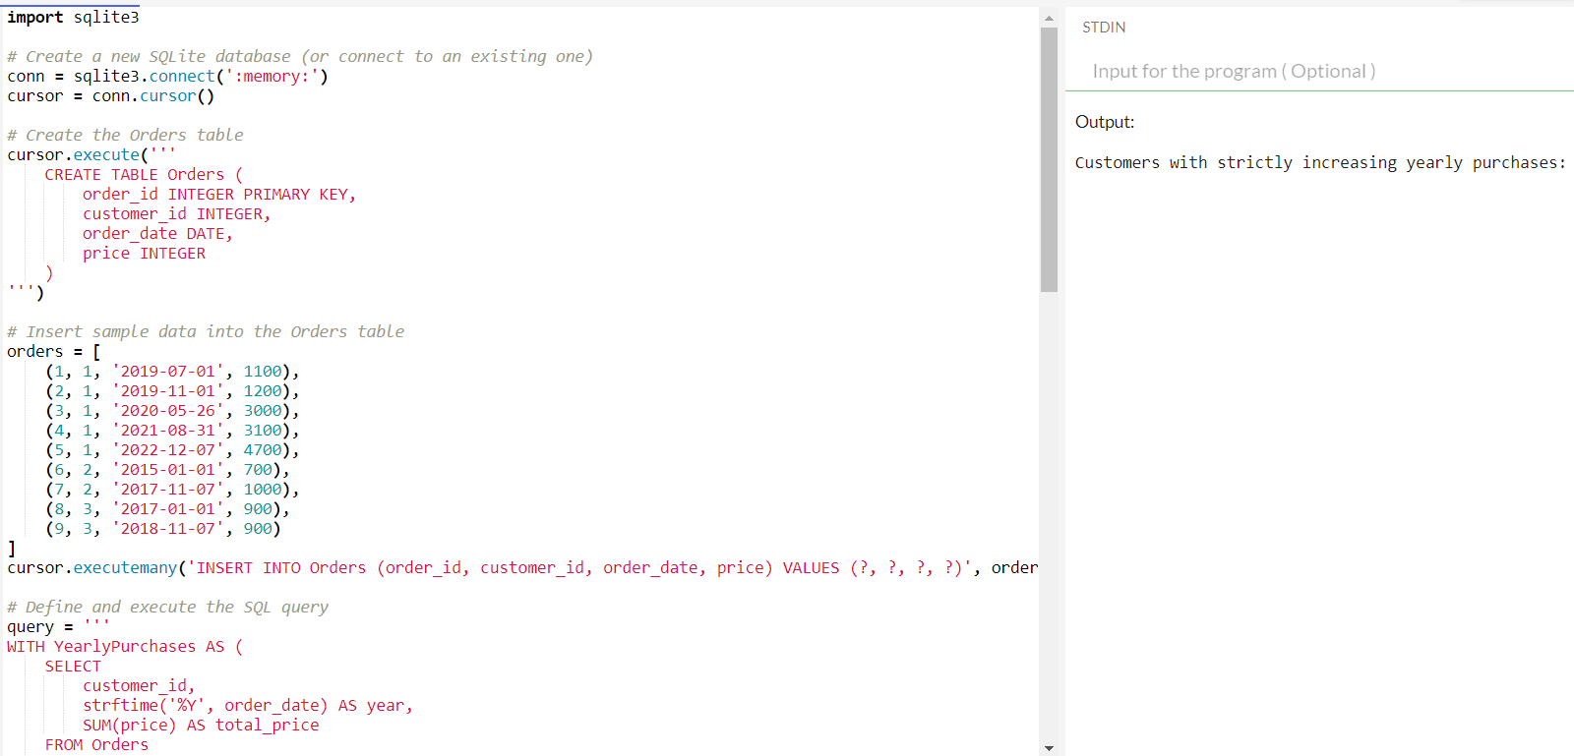

**7) 7.NumberofUnequalTripletsinArray Youaregivena0-indexedarrayofpositiveintegersnums.Findthenumberoftriplets(i,j,k) thatmeetthefollowingconditions: ● 0<=i<j<k**

def countUnequalTriplets(nums):

count = 0

n = len(nums)

for i in range(n):

for j in range(i + 1, n):

for k in range(j + 1, n):

if nums[i] != nums[j] and nums[i] != nums[k] and nums[j] != nums[k]:

count += 1

return count

# Example usage

nums = [4, 4, 2, 4, 3]

print(countUnequalTriplets(nums))

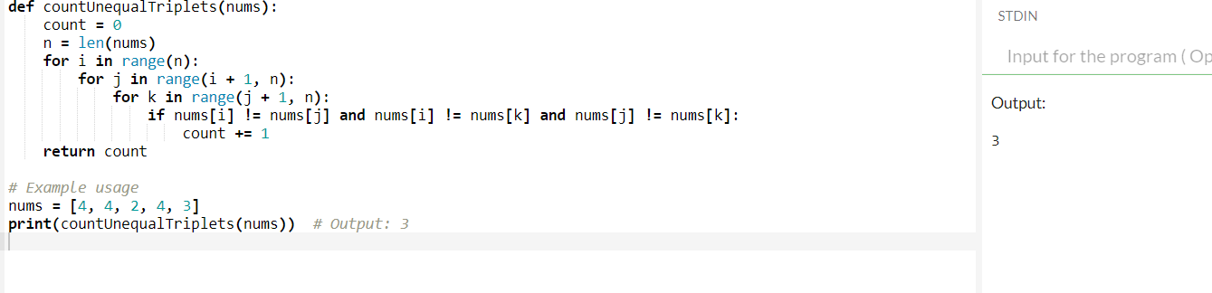

8) 8**.ClosestNodesQueriesinaBinarySearchTree Youaregiventherootofabinarysearchtreeandanarrayqueriesofsizenconsistingof positiveintegers. Finda2Darrayanswerofsizenwhereanswer[i]=[mini,maxi]: ● miniisthelargestvalueinthetreethatissmallerthanorequaltoqueries[i].Ifasuch valuedoesnotexist,add-1instead. ● maxiisthesmallestvalueinthetreethatisgreaterthanorequaltoqueries[i].Ifa suchvaluedoesnotexist,add-1instead.**

class TreeNode:

def __init__(self, val=0, left=None, right=None):

self.val = val

self.left = left

self.right = right

def inorder_traversal(root):

# Perform an inorder traversal to get the node values in sorted order

result = []

stack = []

current = root

while stack or current:

while current:

stack.append(current)

current = current.left

current = stack.pop()

result.append(current.val)

current = current.right

return result

def closest_nodes(root, queries):

# Get the sorted node values from the BST

sorted_values = inorder_traversal(root)

def find_closest_values(query):

import bisect

pos = bisect.bisect_left(sorted_values, query)

mini = -1 if pos == 0 else sorted_values[pos - 1]

maxi = -1 if pos == len(sorted_values) else sorted_values[pos]

if pos < len(sorted_values) and sorted_values[pos] == query:

mini = maxi = sorted_values[pos]

return [mini, maxi]

# For each query, find the closest values

return [find_closest_values(query) for query in queries]

# Example usage

root = TreeNode(6)

root.left = TreeNode(2)

root.right = TreeNode(13)

root. left.left = TreeNode(1)

root.left.right = TreeNode(4)

root.right.left = TreeNode(9)

root.right.right = TreeNode(15)

root.right.right.left = TreeNode(14)

queries = [2, 5, 16]

print(closest_nodes(root, queries))

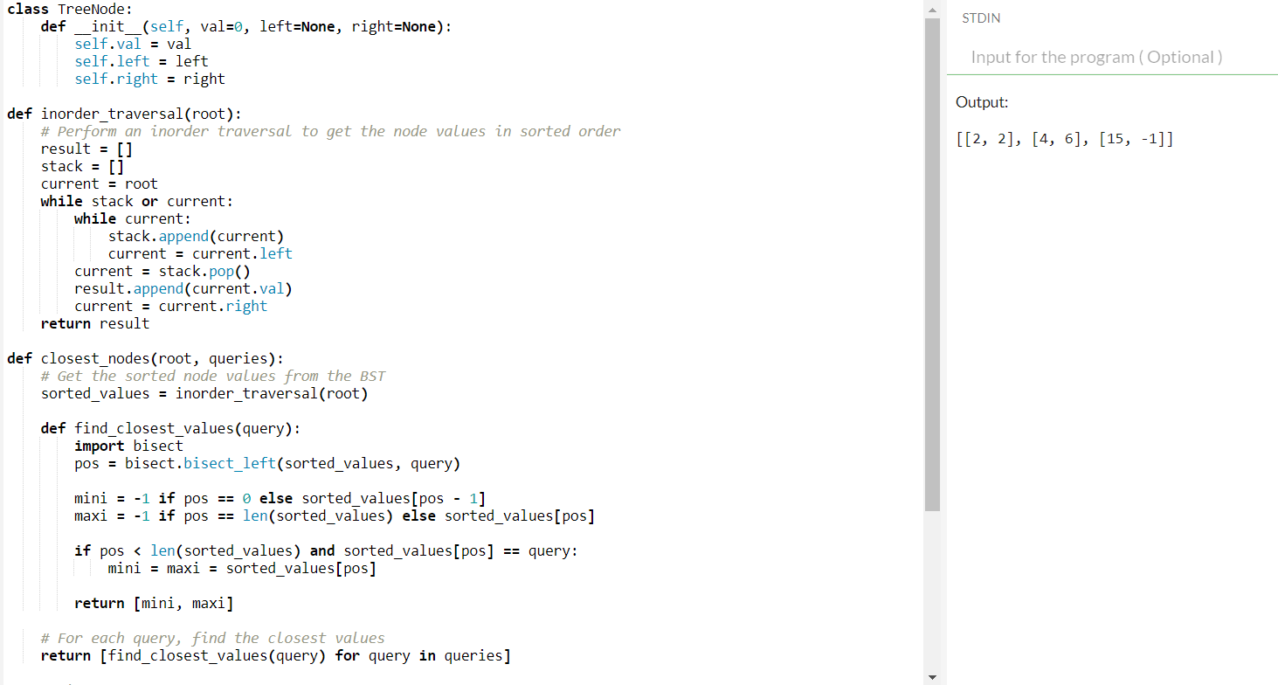

9) **9.MinimumFuelCosttoReporttotheCapital Thereisatree(i.e.,aconnected,undirectedgraphwithnocycles)structurecountrynetwork consistingofncitiesnumberedfrom0ton-1andexactlyn-1roads.Thecapitalcityiscity 0.Youaregivena2Dintegerarrayroadswhereroads[i]=[ai,bi]denotesthatthereexistsa bidirectionalroadconnectingcitiesaiandbi.**

from collections import deque, defaultdict

def minFuel(roads, seats):

n = len(roads) + 1 # number of cities

graph = defaultdict(list)

# Build the adjacency list representation of the graph

for road in roads:

u, v = road[0], road[1]

graph[u].append(v)

graph[v].append(u)

# BFS initialization

queue = deque([0])

visited = [False] * n

visited[0] = True

fuel_needed = [0] * n

while queue:

city = queue.popleft()

for neighbor in graph[city]:

if not visited[neighbor]:

visited[neighbor] = True

queue.append(neighbor)

# Calculate fuel needed to reach neighbor

if seats[neighbor] >= len(graph[neighbor]) + 1:

fuel_needed[neighbor] = fuel_needed[city]

else:

fuel_needed[neighbor] = fuel_needed[city] + 1

return fuel_needed[0]

# Example usage

roads = [[0,1],[0,2],[0,3]]

seats = [5] * 4 # assuming each city has 5 seats available

print(minFuel(roads, seats)) # Output: 3

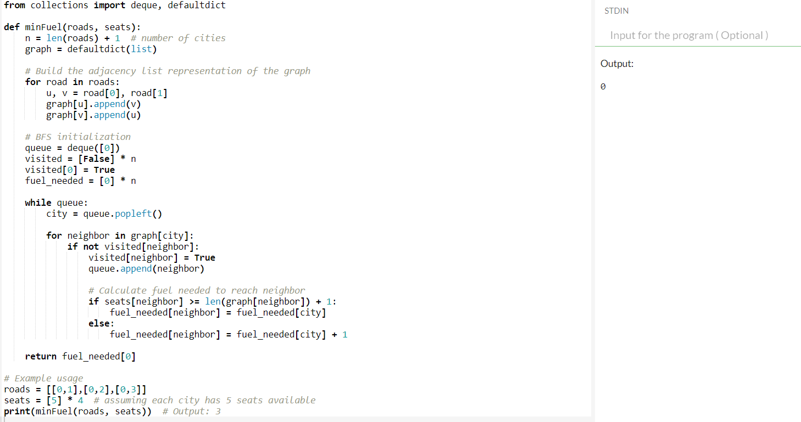

**10) You are given a string s that consists of the digits '1' to '9' and two integers k and minLength. Apartition of s is called beautiful if: ● s is partitioned into k non-intersecting substrings. ● Each substring has a length of at least minLength. ● Eachsubstring starts with a prime digit and ends with a non-prime digit. Prime digits are '2', '3', '5', and '7', and the rest of the digits are non-prime.**

def count_beautiful_partitions (s, k, minLength):

MOD = 10**9 + 7

primes = {'2', '3', '5', '7'}

def is_prime(char):

return char in prime

def is_non_prime(char):

return not is_prime(char)

def is_valid_partition(partition):

return is_prime(partition[0]) and is_non_prime(partition[-1]) and len(partition) >= minLength

def count_partitions(s, k, start, current_partition):

if k == 0:

return 1 if start == len(s)

else 0

count = 0

for i in range(start, len(s)):

current_partition += s[i]

if is_valid_partition(current_partition):

count = (count + count_partitions(s, k - 1, i + 1, "")) % MOD

return count

return count_partitions(s, k, 0, "")

# Example

s = "23542185131"

k = 3

minLength = 2

print(count_beautiful_partitions(s, k, minLength))

